BA 866/7 - Capstone Project

**Modeling for a Tradable Signal**

Spinnaker Analytics

Team B5:

Lujain Alqassar

Yesol Lee

Ta-Wei Wang

Shrey Sood

Yilun Wang

Table of Contents

**Introduction** **2**

Business Plan 3

**Key Findings** **3**

Initial Exploratory Data Analysis: 3

Neural Network Model: 4

Classification Model: 5

Time Series Model: 8

**Limitations** **9**

**Conclusion** **9**

**Business Impact and Implications** **9**

**Avenues for Further Improvement** **9**

# Introduction

Looking into investing in stocks, and the stock market in general, we can see that it is a very volatile and unpredictable area to get into.

As is said in many investment advice: “past performance is not an indicator of future success.” Even though it is hard to indicate future performance, this could not stop us from trying to find a signal to help indicate what future actions we can take to optimize stock buying and selling.

Our client, Spinnaker Analytics, is a high profile software company that provides professional services to businesses and has requested us to help them in finding a possible solution to a question they want answered.

## Business Plan

Finding a tradable signal in all of the datasets that can be used for determining whether to buy or sell a stock portfolio in the future.

In doing so, we want to minimize any possible risk and maximize the profit of the investments for possible clients.

# 

# Key Findings

## Initial Exploratory Data Analysis:

* Notebook Link: <https://colab.research.google.com/drive/145lipLXonuelGF4o5v9FGSADiuMYlGij?usp=sharing>
* Packages: The packages used in the EDA are “pandas” for dataframe utilization, “Numpy” and “math” packages for array calculation, “sklearn” package for regression analysis, “matplotlib” and “seaborn” for plotting graphs.

The following graphs are the heatmap for the Flow between ETF, Institutional Mutual Funds, and Retail Mutual Funds. We can see that the correlation between ETF and Institutional Mutual Funds is higher while correlations for Retail Mutual Funds are lower. On the other hand, the graph on the right demonstrates that all correlations for PortfolioChangePct are extremely high with values of approximately 1. This indicates that the values of PortfolioChangePct align with each other more. 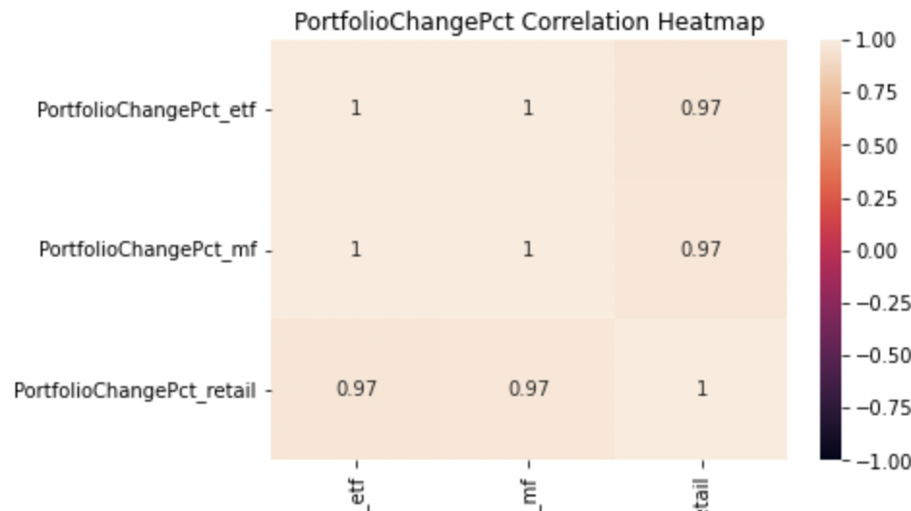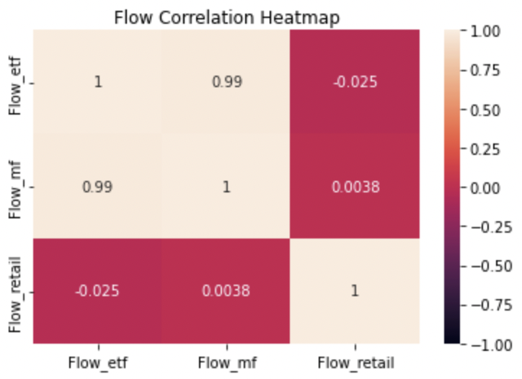

The following graphs are about the Flow trend by year, the red line is Institutional Mutual Fund while the green and blue lines are Retail Mutual Funds and ETF respectively. We can see while Retail Mutual Funds decreased gradually, the other two increased from time to time. However, there are two major incidents where numbers took a huge dip in 2008 and 2014, pointed out with two dotted red lines, where the Global Financial Crisis and the Russian Financial Crisis occurred. On the right is the PortfolioChangePct for each year and the ratios follow each other while almost overlapping. This also means that the PortfolioChangePct follows the overall market more.

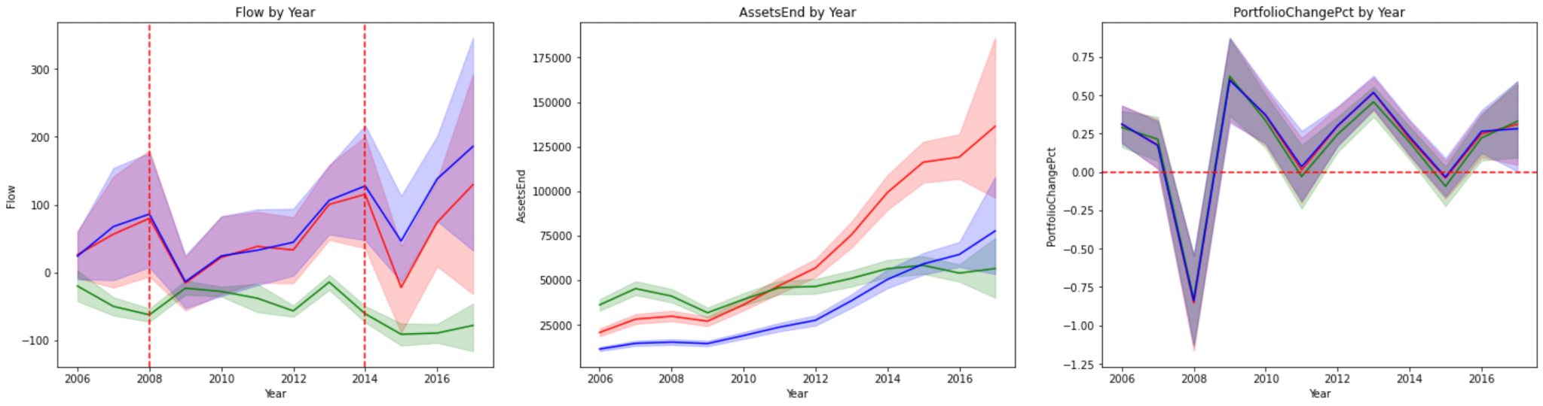

The last two graphs are about average numbers by month. There is a trend that Institutional Mutual Funds and ETFs increased from January to December while Retail Mutual Funds decreased. On the right is the PortfolioChangePct that all three once again correlate with each other.

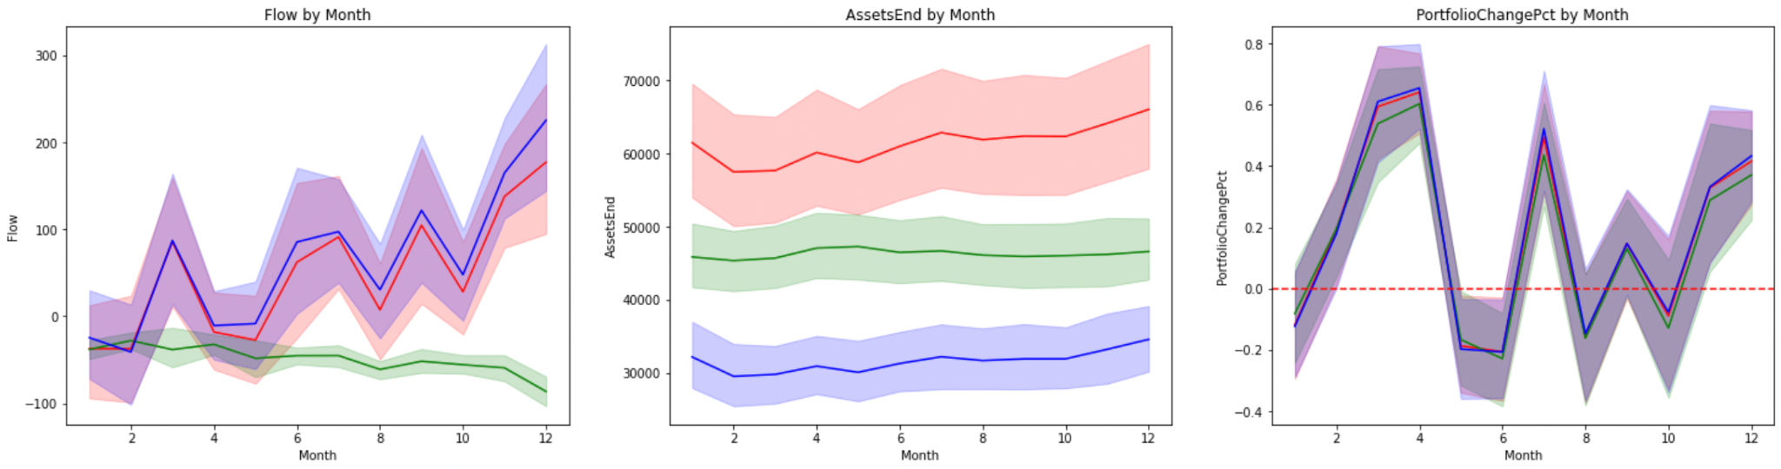

## Neural Network Model:

* Notebook Link:
  + <https://colab.research.google.com/drive/1frgWjb5k8iMUczoZugWJVQ5tv7Eu-LGp?usp=sharing>
  + <https://drive.google.com/file/d/1bq-o9C07Cvj8xAvKxMUC9lmVUwzpsHmb/view?usp=sharing>
* Packages: Pandas, Numpy, Tensorflow, matplotlib, statistics, sklearn, Keras

For the Neural Network Model, first I defined the PortfolioChangePct of next week. Then, I dummified all the asset classes into one-hot encoding variables. For validation, I shuffled and split the dataset with an 80/20 ratio for training and testing. Hence, the shape of the input would be 8518 observations times 24 columns for testing and 2130 observations for testing. With 3 simple dense layers and 200 epochs of training, we are able to decrease the MSE of prediction from 389.4875 to 1.864.

For the LSTM part, I took a rolling window of time approach for determining the input and the number for demonstration is the past 4 weeks in an input. The output is similar to the previous model for predicting next week’s PortfolioChangePct. We also shuffled the data and split it into 80/20 training to testing ratio. For the modeling part, the model is trained separately, with 200 epochs.

Overall, the model results are shown below. Though the average prediction MSEs are low, we got an extremely low and even negative R squared value. Thus, there are better models for our final conclusions.

## 

## Classification Model:

* Notebook Link:
* Institutional MF: <https://colab.research.google.com/drive/14OZKCyKTEsyGPQWEMgUe17Bv-50YEfYy?usp=sharing>
* Retail MF:

<https://colab.research.google.com/drive/183fep-GtaX9tu3BceBvAom8crf2EV6D4?usp=sharing>

* ETF:

<https://colab.research.google.com/drive/1r8oXnwLi5dQ0HoTi_w18esHRlkZQmoRa?usp=sharing>

* Packages: pandas, numpy, matplotlib.pyplot, seaborn, datetime, sklearn, SMOTE, counter

Our team defined tradable signals by using PortfolioChangePCT. We had 2 approaches, aggressive and conservative and used different cut off for each approach. We thought some clients might want to minimize the risk even though their gain would be small. In an aggressive approach we set our cut off as 5, buy for positive, sell for negative and rest are hold. In conservative approach we used 3 instead of 5.

In the classification model, our goal was to predict the Next week’s tradable signal by using this week’s data. We tried out 4 different classification algorithms, logistic regression, decision tree, random forest and XGBoost. We had 3 metrics to compare different algorithms, which are F1 score, AUC score and Accuracy score. F1 score captures models performance by using Positive Predictive Value and True Positive Rate. AUC score measures the model’s ability to separate data points into different classes and Accuracy means how many of the predictions were right. Since our task is multiclass classification and highly imbalance in target variables, we used One over Rest and weighted averaging to calculate F1 score and AUC score. One over Rest method compares each class against all the others at the same time. For example, when we compute AUC for Buy signals in our project, we consider buy class as positive, and Hold and Sell classes as negative and calculate AUC score for the Buy class. After calculating AUC for 3 classes we used weighted average to get one representative figure and to reflect imbalance in the data. We prioritize F1 score but also consider the balance in all metrics. This means that even though certain algorithms have slightly higher F1 scores than other models, if it has low AUC with great difference compared to others, we would not consider it as our best model. Our team fit each model using 70% train data and calculated metrics with 30% test data

| Aggressive Approach | Logistic Regression | Decision Tree | Random Forest | XGBoost |
| --- | --- | --- | --- | --- |
| F1 score | 70.15% | 89.68% | 89.34% | 89.58% |
| AUC score | 67.66% | 67.32% | 68.46% | 73.1% |
| Accuracy | 59.27% | 92.94% | 92.12% | 97.97% |

| Conservative  Approach | Logistic Regression | Decision Tree | Random Forest | XGBoost |
| --- | --- | --- | --- | --- |
| F1 score | 56.91% | 69.64% | 69.95% | 69.43% |
| AUC score | 62.04% | 59.21% | 60.95% | 65.13% |
| Accuracy | 50.7% | 78.12% | 75.3% | 78.76% |

< Tested Algorithms and Evaluation Metrics on Institutional Mutual Fund Data >

We chose XGBoost for our best algorithm because it has high F1 score, AUC score and Accuracy score. Then we fine tuned the algorithm via the GridSearchCV method. We tested 72 combinations of learning rate, max depth, and number of estimators. Our goal in parameter tuning was to prevent both overfitting and underfitting.

When we compared the performance of the tuned XGBoost model and the baseline XGBoost model, we found that the tuned model tends to separate more data points into Buy and Sell classes. The baseline model, on the other hand, predicted all the data points into Hold class. The problem is that the tuned model’s prediction had a really low F1 score, Precision and Recall for Buy and Sell signals. Our team thought that this is because of an imbalance in the data and decided to oversample and see how performance changed after resampling.

| Institutional Mutual Funds Data | Aggressive Approach | | Conservative Approach | |
| --- | --- | --- | --- | --- |
| Before resampling | After resampling | Before resampling | After resampling |
| F1 score of Model | 90.88% | 69.68% | 72.77% | 75.90% |
| AUC | 72.93% | 86.73% | 62.04% | 90.32% |
| Accuracy | 93.43% | 70.1% | 78.31% | 75.91% |
| F1 score of Sell | 3.12% | 58.01% | 4.98% | 74.71% |
| F1 score of Hold | 96.66% | 79.59% | 88.25% | 77.19% |
| F1 score of Buy | 8.16% | 71.25% | 9.45% | 75.80% |
| Recall of Sell | 1.69% | 50.12% | 3.06% | 73.59% |
| Recall of Hold | 93.95% | 74.73% | 95.67% | 78.66% |
| Recall of Buy | 4.76% | 85.06% | 6.38% | 75.50% |

< Comparing model’s result of before resampling and after resampling >

Our team found that the model level F1 score went up because we were using the weighted average. Since the Hold class has the most data in our dataset, when we calculated the weighted average F1 score, it overlooked the very low F1 score of Sell and Buy classes. After resampling, we can see that the F1 score of Sell and Buy increased a lot. We concluded that using a tuned model on resampled data is more reasonable. Even though model level F1 score dropped in aggressive approach, having balanced metric for all three classes is more desirable. Moreover, wrong decisions in investment can bring about huge losses. So it is important to have a high true positive rate and reduce false negatives. Our team iterated this whole process in all 3 data sets.

## Time Series Model:

* Notebook Link:
  + <https://drive.google.com/file/d/1arnBw-ZM3u5SRdh9IjwICy9yaMfo6x3s/view?usp=sharing>
* Packages used: pandas, numpy, seaborn, sklearn, pmdarima, statsmodel, SARIMAX.

We used 4 different ARIMA models to predict Flow, FlowPct, AssetsEnd and PortfolioChangePct respectively. We mainly focussed on the institutional mutual funds dataset as there was high correlation between various attributes across all the three datasets.

* Firstly we divided the dataset into an 80-20 train-test split maintaining the order of the rows since it’s an imperative factor while making predictions using a time series model.
* Then we trained our model using the training dataset and feeding it into SARIMAX in order to obtain the best order value of our model.
* After we had the order value, we used it to train our ARIMA model and make predictions for our validation dataset. We also calculated the Mean Squared Error for our validation dataset by taking a mean square difference of our predicted values and the actual values in the dataset.
* We also used the dickey-Fuller test to calculate the AUC score, critical values (1%, 3%, 10%) and also to determine the significance of our attributes by calculating the p-values.

The MSE values for our validation dataset are given below:

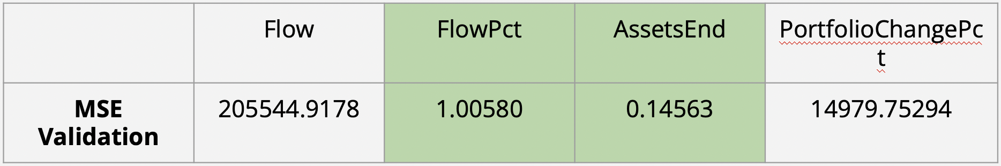

From the above values we can conclude that the best predictions were made for FlowPct and AssetsEnd since they have the lowest MSE score as compared to Flow and ProtfolioChangePct. The ideal reasons to explain the huge difference between their MSE’s could be that Flow and PortfolioChangePct are highly volatile and erratic in nature hence our model was unable to comprehend the abrupt changes in the values feeded into it.

Final Results:

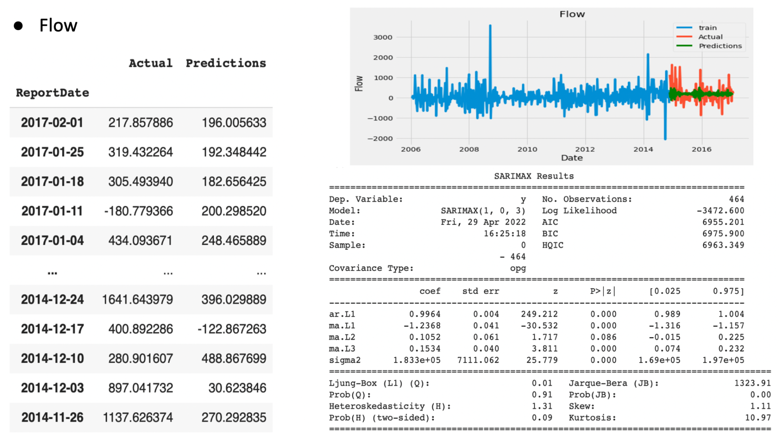

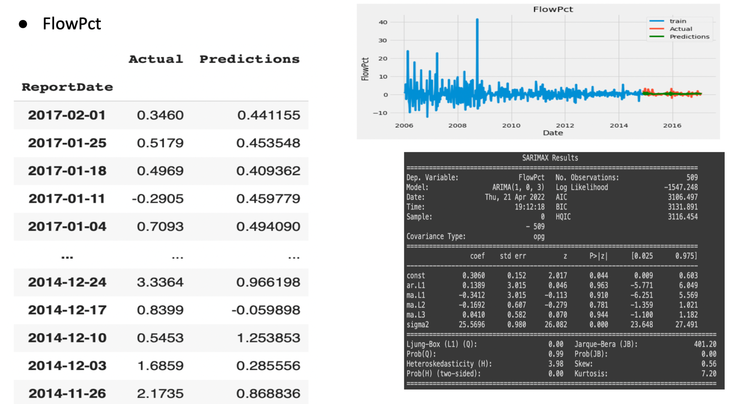

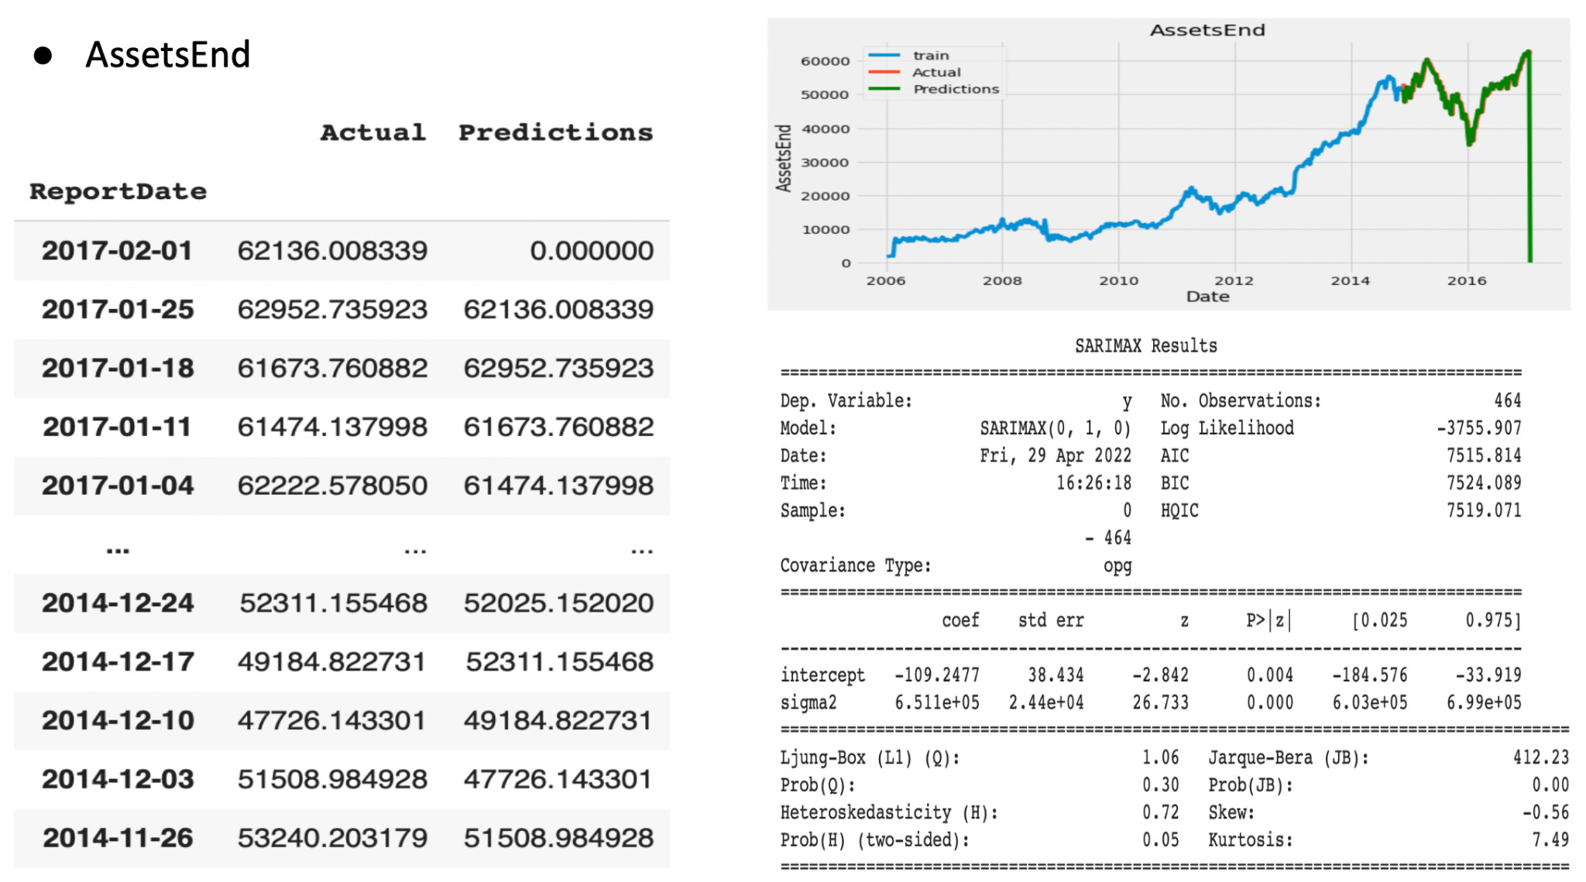

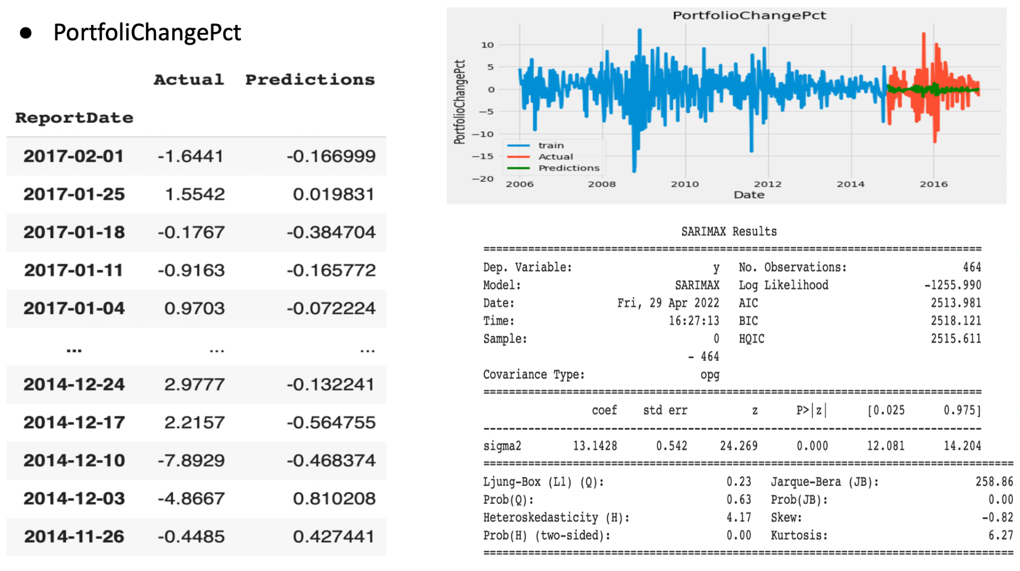

# 

# Limitations

We dealt with a lot of limitations while working on this project some of which include the following:

1. **Time constraints**. Some issues we dealt with were the time constraints we faced in completing this project, especially with all the other responsibilities that we had to deal with. Additionally, we also had issues in determining what was the best time range to choose for the models for predicting the tradable signal based off of the PortfolioChangePct.
2. **Limited data - we didn’t have enough predictive variables**. In our datasets, we only had approximately 4 different factors, such as the Flow, FlowPct, AssetsEnd, and AssetClass. We feel that that might not be sufficient predictive variables to help determine the tradable signal in our dataset.
3. **Not enough subdivided trade signals**. Currently, we only have a Buy, Sell, and Hold signal. Having only three signals could not be enough and dividing up our signals more in depth might have been a step forward that could have led to better performance.
4. **Unpredictability of the stock data**. Overall, stock data is very unpredictable, and even with some many different predictors, it will be extremely difficult to detect an accurate tradable signal. That knowledge is something we must take into account whenever we try to build a model that aims in predicting actions to take in investment decisions.

# Conclusion

After evaluating all the different models that were created, we decided that the best model to help determine a tradable signal in the dataset is the tuned resampled classification model. It had the best performance metrics from all other models. Even though it was the best option from what was available, it is important to note that predicting future stock events is almost impossible to do.

# 

# Business Impact and Implications

After choosing our final best model, we can implement it in a variety of ways in making business and stock investment decisions. With this model, we can provide investment strategies and asset class reports using weekly probability predictions of a tradable signal.

For example, in our Retail Mutual Funds Conservative Approach dataset model, we got the following predictive probabilities:

| Sell | Hold | Buy |
| --- | --- | --- |
| 13.38% | 20.12% | 66.50% |

For the observation with these values:

| Asset Class | Flow Pct | Flow | Assets End |
| --- | --- | --- | --- |
| Commodities/Materials-North America-USA-North America-Equity | -6.68% | 0.33 | -0.64 |

* Flow and AssetsEnd are scaled

With the results we presented, we would recommend a business to buy the stock if it had the following classifications in terms of Flow Percent, Flow, and Assets End, as well as from the Commodities/Materials class for North America if we wanted to follow the conservative approach. We could also determine what the best predictive probabilities of action to take for the aggressive approach.

# Avenues for Further Improvement

In our final model, we see that there are many avenues for further improvement. Much can be done to improve the performance of the model to better predict future stock performance. Some of the future enhancement recommendations for the resampled tuned classification model are:

1. **Adding more financial characteristic variables into our datasets**. At the moment, we only had 5 different predictive variables in our dataset. Given the unpredictability of the stock market, a lot more financial data would be needed to help determine a tradable signal.
2. **Including more subdivided tradable signals**. Instead of our initial signals of Buy/Hold/Sell, we can go on to create more divisions, such as Strong Buy/Weak Buy, Strong Sell/Weak Sell, and Hold.
3. **Trying out more advanced modeling methods**. Some examples could be transfer learning or more in-depth neural networks, and other types of time series models in addition to what we already did throughout this project.